**Business Concept: Bid optimization**

* Analyzing for bid optimization is about understanding the value of various segments for paid traffic, so that you can optimize your marketing budget.

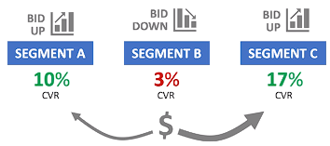

* Common use cases:

1. Using conversion rate and revenue per click analyses to figure out how much you should spend per click to acquire customers

* Bid optimization in this context involves determining the optimal amount to bid on keywords or advertising placements to maximize return on investment (ROI) based on conversion rate and revenue per click metrics.
* Example: Suppose you run an online bookstore. Through analysis, you find that clicks from users searching for "fiction books" have a higher conversion rate and generate more revenue per click compared to clicks from users searching for "cookbooks." With bid optimization, you can adjust your bids to allocate more budget towards "fiction books" keywords, as they yield better results in terms of acquiring customers.

1. Understanding how your website and products perform for various subsegments of traffic (i.e., mobile vs desktop) to optimize within channels

* Bid optimization here involves adjusting bids based on the performance of different traffic segments, such as mobile versus desktop users, to maximize the effectiveness of advertising spend within each channel.
* Example: Imagine you manage an online electronics store. Analysis reveals that users browsing on desktop computers tend to spend more and have higher conversion rates compared to users on mobile devices. With bid optimization, you can adjust your bids to prioritize desktop traffic, ensuring that you allocate more budget to channels that yield better results in terms of sales and conversions.

1. Analyzing the impact that bid changes have on your ranking in the auctions, and the volume of customers driven to your site

* Bid optimization in this scenario involves monitoring the effects of bid adjustments on ad positioning and traffic volume, and making strategic bid changes to achieve desired outcomes such as increased visibility and website traffic.
* Example: Suppose you manage a travel agency's online advertising campaigns. By experimenting with bid adjustments for keywords related to "beach vacations," you observe that increasing your bids results in higher ad positions in search results, leading to a significant increase in clicks and website visits. Through bid optimization, you can continuously monitor bid changes and their impact on ad performance, adjusting bids to maintain optimal positioning and drive desired levels of traffic to your site.
* **MySQL Date functions**: Month(), Year(), Week(), etc. Google date functions anytime when need to work with dates.
* Use date function with GROUP BY, to make the function powerful, and aggregate functions like COUNT() and SUM() to show trending and do trending analysis.

**PRO TIP: ‘PIVOTING’ data with COUNT and CASE**

select primary_product_id,

count(case when items_purchased = 1 then order_id else null end) as single_item_orders,

count(case when items_purchased = 2 then order_id else null end) as two_item_orders

from orders

where order_id between 31000 and 32000 -- arbitrary number

group by 1;

**BUSINESS CONCEPT: ANALYZING TOP WEBSITE CONTENT**

* Website content analysis is about understanding which pages are seen the most by your users, to identify where to focus on improving your business.

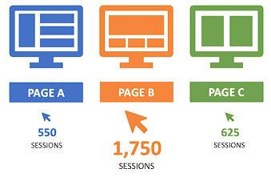

* Common use cases:
* Finding the most-viewed pages that customers view on your site
* Identifying the most common entry pages to your website – the first thing as user sees
* For most-viewed pages and most common entry pages, understanding how those pages perform for your business objectives
* **CREATING TEMPORARY TABLES:**
* Allows you to create a dataset stored as a table which you can query.
* It only persists only for the current workbench session. So, save your code
* Use temporary tables to perform multi-step analyses
* **Finding top pages**:
* We can analyze our pageviews data and group by url to see which pages are viewed the most
* To find top entry pages, we will limit to just the first page a user sees during a given session, using a temporary table

**BUSINESS CONCEPT: ANALYZING TOP WEBSITE CONTENT**

* Landing page analysis and testing is about understanding the performance of your key landing pages and then testing to improve your results.

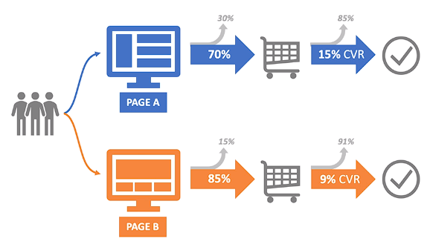

* Common use cases:
* Identifying your top opportunities for landing pages – high volume pages with higher than expected bounce rates or low conversion rates
* Setting up A/ B experiments on your live traffic to see if you can improve your bounce rates and conversion rates
* Analyzing test results and making recommendations on which version of landing pages you should use going forward
* **LP Performance and testing:**
* To analyze landing page performance and compare multiple pages, we will again use temporary tables and write a multi-step “data program”.
* We will find the first pageview for relevant sessions, associate that pageview with the url seen, then analyze whether that session had additional pageviews.
* Note on programming: If you know what results you are looking for at the end, don’t lose those results in the middle. Try to take the column everywhere with and perform joins with it.

**BUSINESS CONCEPT: ANALYZING and TESTING CONVERSION FUNNELS**

* Conversion funnel analysis is about understanding and optimizing each step of user’s experience on their journey towards purchasing the products.

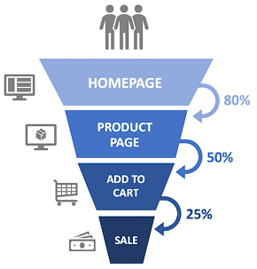

* Common use cases:

1. Identifying the most common paths customers take before purchasing your product
2. Identifying how many of your users continue on to each next step in your conversion flow, and how many users abandon at each step
3. Optimizing critical pain points where users are abandoning, so that you can convert more users and sell more products

* **Key table for conversion funnels: website_pageview**
* When perform conversion funnel analysis, we look at each step in our conversion flow to see how many customers drop off and how many continue on at each step
* **USING SUBQUERIES:**
* Allows you to query another query (similar to temporary tables)
* NOTE: The subquery inside the brackets must meet the two criteria:

1. It must be a complete query on its own
2. It must be given as alias

* **TIP: Subqueries and temporary tables perform very similar functions Subqueries can be a little quicker to write simple tasks, but can become very to follow for longer multi-step analyses**
* Conversion Funnels:
* We will create temporary tables using pageview data in order to build multi-step funnels
* We will first identify the sessions we care about, then bring in the relevant pageviews, then flag each session as having made it to certain funnel steps, and finally perform a summary analysis